**Steps to calling FM from Report**

1. Go to se38 and create a Report starting z/y.

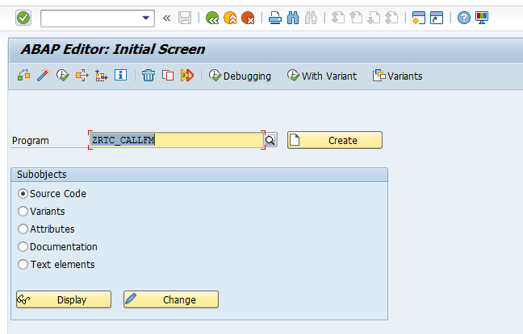

1. Add the below logic in the Report

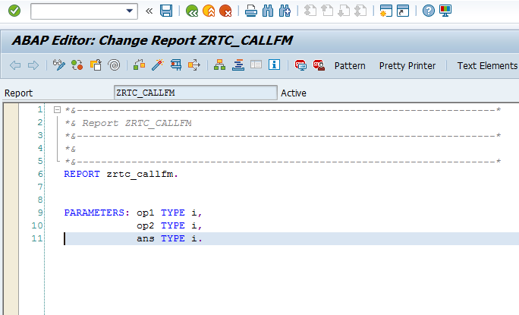

3 . Click on Pattern and give the FM name (created earlier .Eg. ZFM_ADD)

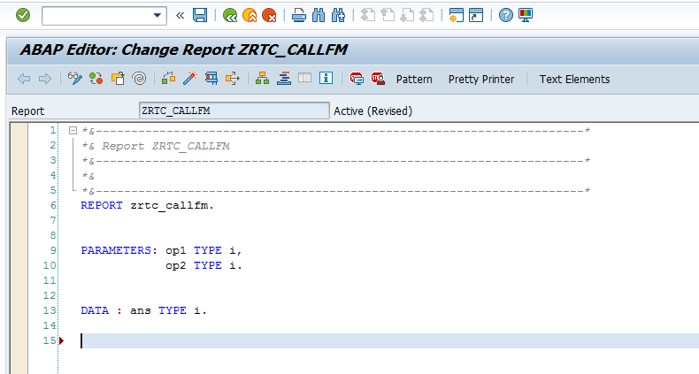

4. Select the radio button Call Function and give the FM name (created earlier) and click on ok.

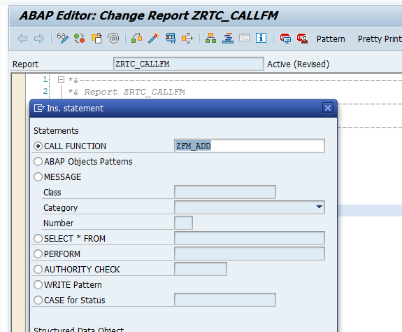

5. The following code gets added to your report.

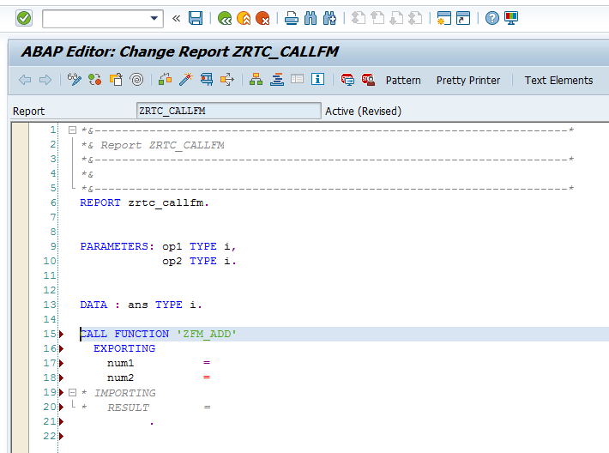

6. Modify the logic as below.

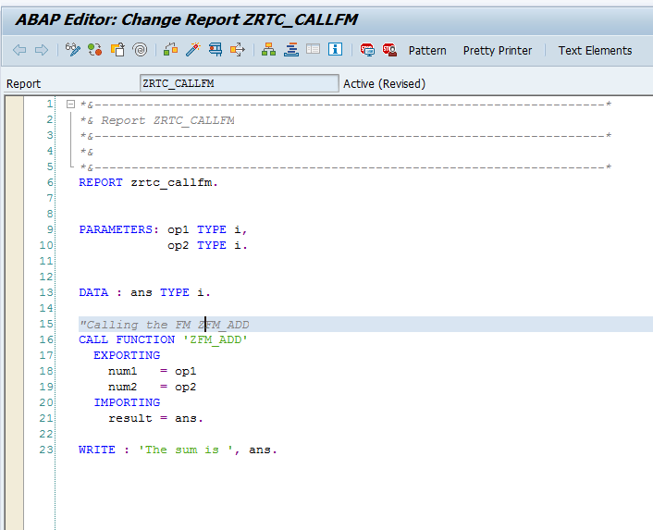

7. The expected output is as below:

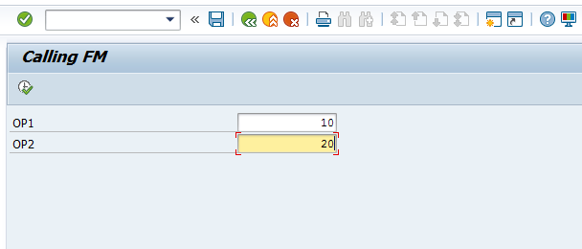

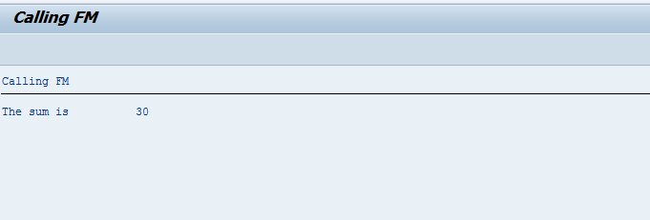

Code:

*&---------------------------------------------------------------------*  
*& Report ZRTC_CALLFM  
*&---------------------------------------------------------------------*  
*&  
*&---------------------------------------------------------------------*  
REPORT zrtc_callfm.  
  
  
PARAMETERS: op1 TYPE i,  
            op2 TYPE i.  
  
  
DATA : ans TYPE i.  
  
"Calling the FM ZFM_ADD  
CALL FUNCTION 'ZFM_ADD'  
  EXPORTING  
    num1   = op1  
    num2   = op2  
  IMPORTING  
    result = ans.  
  
WRITE : 'The sum is ', ans.